Prior Knowledge

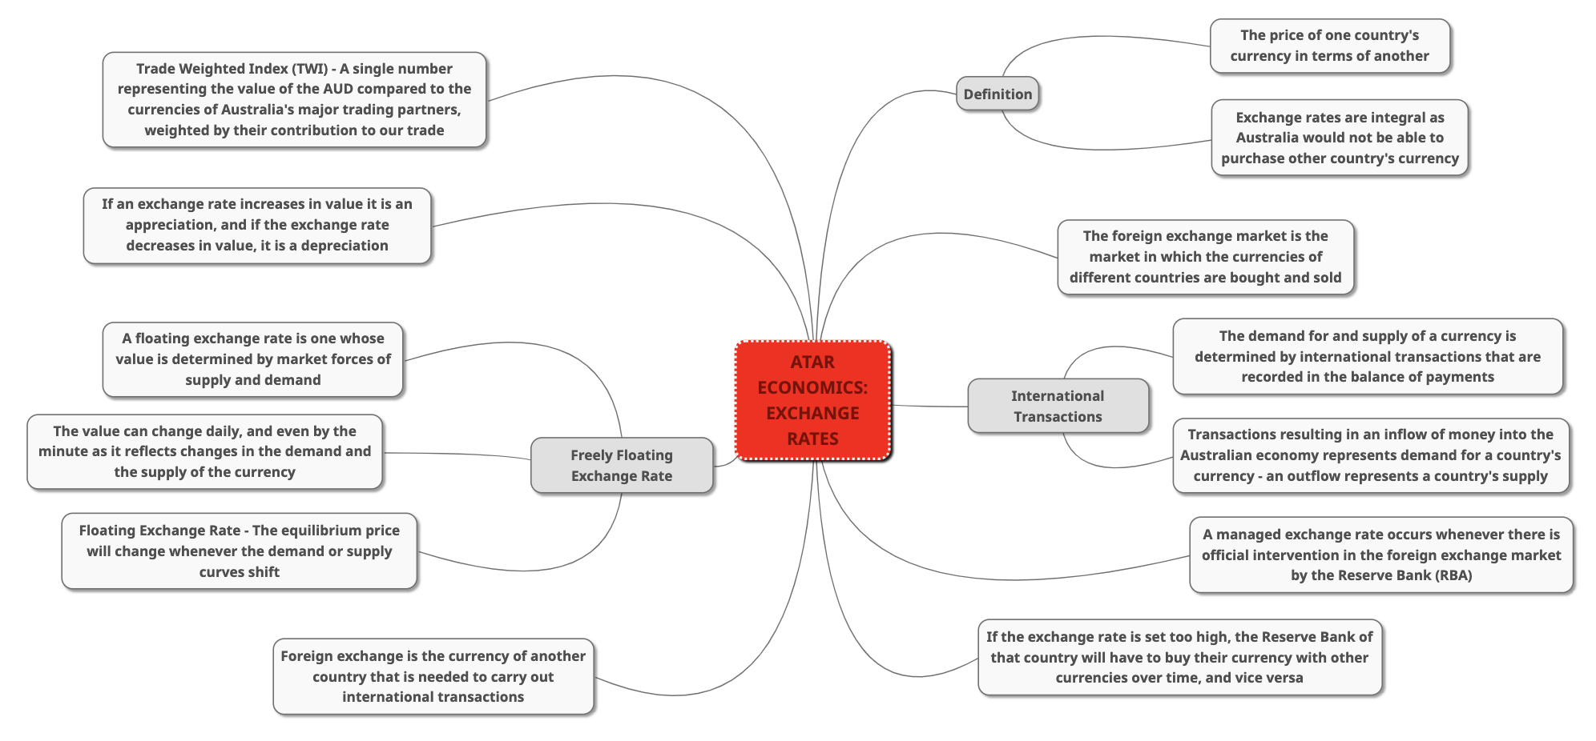
Focus Questions

- What are the main factors affecting the Australian exchange rate?
- What is an exchange rate and why is it necessary?
- What is a bilateral exchange rate?
- What is the trade-weighted index (TWI)?
- What is the foreign exchange market and what is its importance to Australian buyers and sellers?
- What is the link between the balance of payments and the exchange rate?
- Distinguish between the demand and supply of a currency.
- Explain what a freely floating exchange rate is, and how it is determined.
- What are the advantages of a freely floating exchange rate?
- Explain the recent changes to the AUD exchange rate (past 5 years).

Time Plan

Planning | 1 hour – prior knowledge, focus questions, resource plan
Research | 3 – 5 hours – answering focus questions, retrieving sources of information (data, statistics, graphs), retrieving news articles
Analysing | 3 – 5 hours – analysis of answers, statistics, and articles (synthesise argument)
Communication | 1 hour (in class) – written response based on the question

Resource Plan

- Parry, G. and Kemp, S., 2021. Investigating Macroeconomics. 6th ed. South Perth: Tactic Publications PTY LTD, pp.105-124.

- Hamilton, A., 2021. Understanding Exchange Rates and Why They Are Important | Bulletin – December Quarter 2018. [online] Reserve Bank of Australia. Available at: <https://www.rba.gov.au/publications/bulletin/2018/dec/understanding-exchange-rates-and-why-they-are-important.html> [Accessed 8 April 2021].

- Tradingeconomics.com. 2021. Australian Dollar | 1971-2021 Data | 2022-2023 Forecast | Quote | Chart | Historical. [online] Available at: <https://tradingeconomics.com/australia/currency> [Accessed 8 April 2021].

- Reserve Bank of Australia. 2021. Exchange Rates. [online] Available at: <https://www.rba.gov.au/statistics/frequency/exchange-rates.html> [Accessed 8 May 2021].

- Collie, B., 2021. The US-China Trade War and the Impacts on Australia. [online] Scotch.vic.edu.au. Available at: <https://www.scotch.vic.edu.au/media/261186/Ben%20Collie%20The%20US-China%20Trade%20War%20and%20the%20Impacts%20on%20Australia.pdf> [Accessed 10 May 2021].

- Tibbitt, A., 2021. Economics ATAR Course Units 3 & 4. 1st ed. Academic Group Pty Ltd, pp.91-106, 270-275.
- What are the main factors affecting the Australian Exchange Rate?

There are various factors that affect the value of a country’s currency. Anything affecting demand for a country’s goods and services from overseas buyers or affects the flows of foreign investment is reflected in the Australian exchange rate. The main factors include:

- Relative inflation rates – Inflation in Australia relative to other countries reduces the competitiveness of industries in the traded goods sector. A high domestic inflation rate will decrease the exchange rate (decline in D(AUD) and increase in S(AUD)).
- Movements in the terms of trade – Movements in the ToT have a major influence on Australia’s exchange rate. When the terms of trade increase, the demand for the Australian dollar increases and the currency appreciates.
- International capital flows – If investors believe Australia to be a relatively more attractive destination for their funds compared to other economies, then the demand for the AUD will increase and it will appreciate.
- Domestic economic growth – Strong economic growth in Australia will lead to an increase in demand for imports, which will increase the supply of the AUD causing a depreciation in the currency, at the same time however, a stronger economy will attract more foreign investment which will increase the demand for the AUD therefore increasing the exchange rate.
- World economic growth – An increase in global GDP increases world commodity prices which increases the demand for the AUD and appreciates the currency.
- Relative interest rates (the interest rate differential) – If interest rates in the US rise relative to Australia, then there will be a decrease in capital inflow to Australia and an increase in capital outflow. This means that the demand for the AUD will decrease and the supply for the AUD will increase, causing a strong depreciation in our currency.

- What is an exchange rate and why is it necessary?

An exchange rate is the price of one currency expressed in terms of another currency or group of currencies. For small open economies (such as Australia’s that actively engage in international trade), the exchange rate is a highly important economic variable. Movements in the exchange rate influences the decisions of individuals, businesses, and the government. Collectively this affects economic activity, inflation, and the balance of payments.

- What is a bilateral exchange rate?

A bilateral exchange rate refers to the value of one currency relative to another. Bilateral exchange rates are the most commonly references type of exchange rate. Most bilateral exchange rates involve the US dollar as it is the most traded currency on a global scale. In comparison to the AUD, the AUD/USD exchange rate provides you with the number of US dollars that you will receive for each Australian dollar sold. E.g., an AUD/USD exchange rate of 0.75 means that you receive 75 cents USD for every 1 AUD.

- What is the trade-weighted index (TWI)?

The trade-weighted index captures the price of a domestic currency in terms of a weighted average of a basket of foreign currencies. The weights are based on the composition of Australia’s goods and services trade for the latest year. The RBA publishes a TWI for the AUD each day. The TWI provides of a measure of whether the Australian dollar is rising or falling on average against the currencies of Australia’s trading partners. The TWI is helpful is understanding more about Australia’s overall trade competitiveness. This is particularly useful when bilateral exchange rates are moving in different directions. For example, the AUD could be rising against the USD but falling in other countries.

- What is the foreign exchange market and what is its importance to Australian buyers and sellers?

The foreign exchange market is the market in which the currencies of different countries are bought and sold. Foreign exchange is the currency of another country that is needed to carry out international transactions. The foreign exchange market between Australian dollars and United States dollars consists of two groups of people – those demanding USD (Australian importer of US goods) and those demanding the AUD (an American importer of Australian goods). It is important as it determines the prices of our currency needed to buy other countries’ currencies.

- What is the link between the balance of payments and the exchange rate?

Movements in the exchange rate has consequences for the balance of payments. To demonstrate this, we use an example of a depreciation of the Australian dollar to describe these effects. The direct effect of an exchange rate depreciation is to increase the price of imports relative to exports, which will tend to decrease the value of net exports (exports less imports) and widen the CAD. The indirect effects of a depreciation increase the volume of exports and reduce the volume of imports, having an offsetting effect and increasing net exports and reducing the CAD. The direct effect of an exchange rate depreciation occurs immediately, while the indirect effects typically occur with a lag. Exchange rate movements also affect the net income deficit. A depreciation will increase the cost to Australian residents of servicing foreign debt that is denominated in foreign currency – this is because the amount of AUD required to purchase the foreign currency needed to pay interest owed on debt has increased. This increases net income outflow and widens the current account deficit.

- Distinguish between the demand and supply of a currency.

The demand for and the supply of a currency are determined by the international transactions that are recorded in the balance of payments. All transactions that result in an inflow of money into the Australian economy, in both the current account and the capital and financial account, represent a demand for a country’s currency. Transactions that result in an outflow of money represent the supply of a country’s currency. The demand for a currency will be determined by exports of goods and services, receipts of income from overseas and capital inflow (foreign investment into Australia). The supply of a currency will be determined by imports of goods and services, payment of income to overseas and capital outflow (Australian investment abroad).

- Explain what a freely floating exchange rate is, and how it is determined.

A floating or free exchange rate is one whose value is determined by the market forces of supply and demand. Its value can change daily, even by the minute or the second as it reflects changes in the demand and the supply of its currency. A freely floating exchange rate is a common type of regime among the world’s major advanced economies as it can contribute to macroeconomic stability by cushioning economies from shocks and allowing monetary policy to be focused on targeting domestic economic conditions.

- What are the advantages of a freely floating exchange rate?

The floating exchange rate acts as a stabiliser to assist the economy in adjusting to external economic events. A key example is Australia’s recent mining boom. During the boom, the appreciation of the Australian dollar was a key factor in the reallocation of labour and capital to the booming mining sector by raising costs and reducing demand for the output of other sectors that did not directly benefit from higher commodity prices. This assisted in reducing labour shortages and inflationary pressures.

A floating exchange rate also helps to reduce swings in the current account balance. Usually, a fall in the balance on trade will lead to an exchange rate depreciation. This increases the price of imported goods and services and decreases the price of Australian exports. Demand for imports should fall following a lag while demand for exports will be increased, thus reducing a trade deficit.

- Explain the recent trends in the AUD exchange rate (past 5 years).

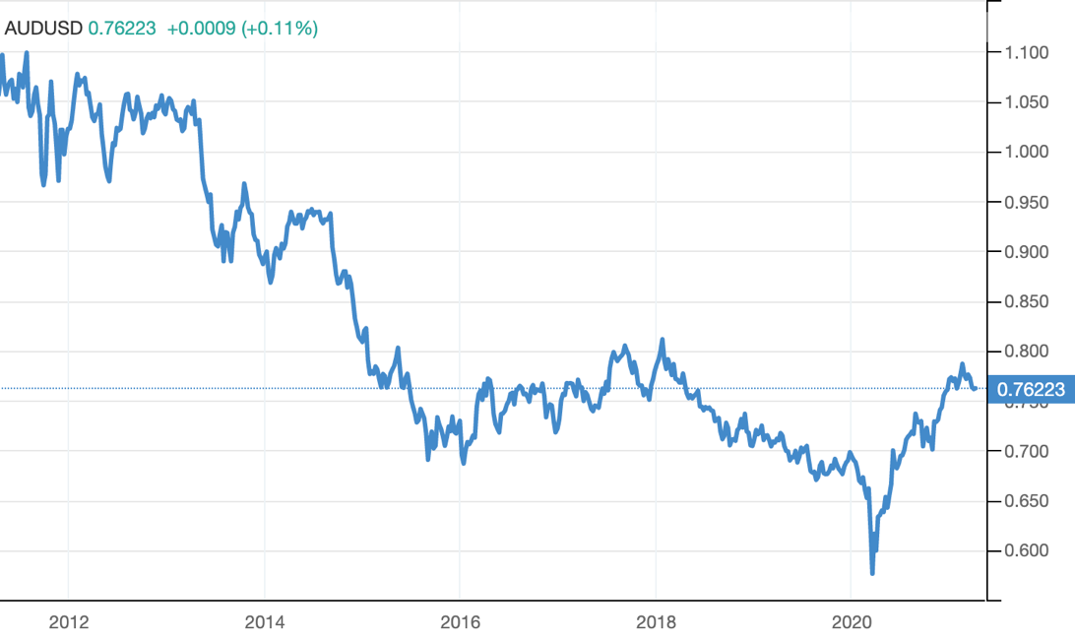
The exchange rate changes whenever demand, or supply conditions change. An exchange rate appreciation will occur if either the demand for the currency increases or the supply of the currency decreases. The AUD exchange rate has been highly volatile since 2010. Between 2010 and 2020, the Australian dollar fluctuated between USD0.62 and USD1.10. During the period shown in the graph, the average value for the Australian dollar was 0.84USD, well above its long-term average of USD0.76. Between 2010 and June 2012, the AUD appreciated against the USD. In July 2011, the AUD reached its highest value since the dollar was floated in 1983 (USD1.10). This was the peak of Australia’s mining boom, fuelled by strong demand by China for Australia’s mining resources. Australian terms of trade also reached their highest level at this time. The mining construction boom ended in 2012 with the decline in commodity prices (especially iron ore and coal), and as a result the Australian dollar depreciated relatively quickly, falling to USD0.70 by September 2015. Between 2016 and 2018, the AUD began appreciating again as commodity prices rose and Australian mining exports increased. In January 2018, the AUD had risen to USD0.81. During 2018 and 2019, the AUD depreciated significantly as the world economy slowed. The COVID-19 pandemic of 2020 saw the AUD fall to just USD0.62 – its lowest level in over a decade.
Research

Recent trends in the AUD exchange rate

- The exchange rate changes whenever demand, or supply conditions change
- An exchange rate appreciation will occur if either the demand for the currency increases or the supply of the currency decreases
- A depreciation is the opposite to an appreciation – the value of the exchange rate falls due to either a decrease in demand for the currency or an increase in the supply of the currency
- The figure shows the volatility of the AUD exchange rate since 2010
- The graph records movements in the Australian dollar against the US dollar and the trade weighted index (TWI)
- The TWI is a weighted average of a basket of currencies that reflects the importance of Australia’s trade by country
- The most important currencies in Australia’s TWI are the Chinese renminbi, the Japanese yen, the US dollar, and the euro – these four currencies make up 60% of the index
- The TWI is considered a better indicator of general movements in the value of the Australian dollar than any single exchange rate
- Between 2010 and 2020, the Australian dollar fluctuated between USD0.62 and USD1.10 and between 55 and 79 on the trade weighted index
- During the period shown in the graph, the average value for the Australian was USD0.84 – well above its long-term average USD0.76
- Notice how closely the two exchange rates track one another – it is important to remember though, that the TWI does not fluctuate as much since it is an average of Australia’s major trading currencies
- Between 2010 and June 2012, the Australian dollar appreciated against both the USD and the TWI
- In July 2011, the AUD reached its highest value since the dollar was floated in 1983 of USD1.10
- This was the peak of Australia’s mining boom – fuelled by strong demand by China for Australia’s mining resources – it is no coincidence that Australia’s terms of trade also reached their highest level at this time
- The mining construction boom ended in 2012 with the decline in commodity prices (especially iron ore and coal) and a result the Australian dollar depreciated relatively began appreciating again as commodity prices rose and Australia mining exports increased
- In January 2018, the AUD has risen to USD0.81
- During 2018 and 2019 the AUD depreciated significantly as the world economy slowed
- The COVID-19 pandemic of 2020 saw the AUD fall to just USD0.62 – its lowest level in over a decade

* See other sources for research/analysis.

Data Analysis

Exchange rates (AUD/USD) for the past 5 years

2016 | 0.74
2017 | 0.77
2018 | 0.75
2019 | 0.70
2020 | 0.69

- 2017 and 2018 saw the AUD reach its highest point at 0.81
- AUD/USD exchange rate depreciated steadily from 0.80 in January 2017
- This was followed by a rapid depreciation to about 0.65 in February 2020
- When the extent of the pandemic and effect it would have on economies around the world became clear, the exchange rate depreciated rapidly to 0.55
- The AUD did bounce back however, appreciating to 0.75 by September 2020

General economic events and statistics

- Commodity prices had reached a peak in 2011
- Nominal exchange rate began to depreciate in March 2013
- Inflation and wage costs began to fall back
- The real trade-weighted index (TWI) depreciated by about 20%, reversing roughly 35% of the appreciation in the mining investment boom period
- This led to an improvement in Australia’s competitiveness
- Domestic inflation had been relatively low since 2013, however inflation was also low in most of Australia’s trading partners due to the slow absorption of spare capacity created during the GFC
- Between 2016 and 2020, a recession was taking place
- The value of the Australian dollar had been closely following movements in our Terms of Trade, and caused corresponding changes in Australia’s international competitiveness

The US-China Trade War and its statistics

- The trade war began on the 6th of July 2018
- Former US President Donald Trump announced China specific tariffs valued at $34bn USD
- The devaluation of China’s currency had significant effects on Australia as we accounted for 30% of their exports, valued to approximately $140bn AUD
- ASX (Australian Security Exchange) decreased by $50bn

Practice Essay

Describe the recent changes to the Australian exchange rate and their likely impact on the Australian economy. (20 marks)

An exchange rate is the price of one currency expressed in terms of another currency or a group of currencies. For small, open economies such as Australia’s that actively engages in international trade, the exchange rate is a highly important economic variable. Movements in the exchange rate influences the decisions of individuals, businesses, and the government. The Australian economy has been impacted by several events, such as significant economic growth, the COVID-19 pandemic, and the US-China trade war. The exchange rate is an important mechanism for helping the Australian economy adjust to large economic events, having direct and indirect effects on the economy.

The exchange rate has been highly variable over the past 5 years, notably between our main trading partners. Between Australia and the United States, the AUD/USD exchange rate has maintained relatively stable (on average). In 2016, the average closing price was 0.74, 2017 was 0.77, 2018 was 0.75, 2019 was 0.70 and 2020 was 0.69. 2017 and 2018 are notable as the exchange rate reached its highest peak at 0.81. The AUD/USD exchange rate had depreciated steadily from about 0.80 in January 2018, followed by a rapid depreciation to about 0.65 in February 2020. When the extent of the pandemic and the effect it would have on economies around the world became clear, the exchange rate depreciated rapidly to about 0.55c. However, as the economy recovered, the value of the Australian Dollar bounced back, appreciating by September 2020 to about 0.75c.

The exchange rate has not only been affected by the recession caused by the pandemic. Several significant economic events leading up to the pandemic took place. In the decade to 2011, there was a significant rise in global commodity prices that had resulted in an equally significant appreciation of the Australian dollar and a pickup in general price and wage inflation. Australia’s international competitiveness had been declining as production costs rose in comparison to those in other countries. Producers in non-mining areas of the economy that were exposed to foreign competition found it difficult to earn satisfactory profits.

Commodity prices had reached a peak in 2011, and the nominal exchange rate started to depreciate in March 2013. Inflation and wage costs began to fall back. The real TWI exchange rate depreciated by about 20% reversing roughly 35% of the appreciation in the mining investment boom period, leading to an improvement in Australia’s competitiveness. Although inflation in Australia had been relatively low since 2013, inflation was also low in most of Australia’s trading partners due to the slow absorption of spare capacity created during the global financial crisis. Between 2016 and 2020 recession, the value of the Australian dollar had closely following movements in the terms of trade and caused corresponding changes in Australia’s international competitiveness.

The US-China trade war began on the 6th of July 2018 with former US President Donald Trump announcing China specific tariffs valued at $34 billion USD. Actions taken out by both the US and China have compromised Australia’s economical position. The trade war has had significant impacts on Australia’s exports and imports, due to a currency depreciation. Due to the large number of Australian exports (30%) going to China worth ~$140bn AUD, the devaluation of China’s currency impacted significantly on Australia, decreasing the ASX (Australian Security Exchange) by $50bn AUD, impacting Australian exports as they became more expensive to import due to China’s weaker dollar.

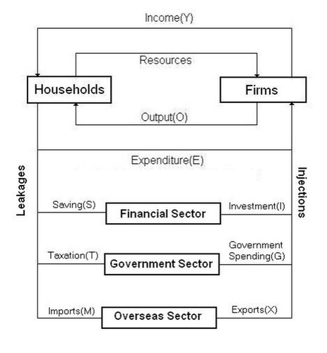
Other things being equal, a weaker exchange rate will lead to an overall rise in aggregate demand resulting from a rise in net exports and a rise in foreign investment, offsetting a reduction in consumption due to a rise in the cost of living and a fall in aggregate supply due to a rise in the cost of imported capital equipment and intermediate goods. Our exchange rate became notably weak in the 2020 recession, dipping to 0.55c (AUD/USD).

A depreciation in our currency will affect three main macroeconomic objectives. Economic growth will become faster and will rise, assuming the shift in aggregate demand outweighs the shift in aggregate supply. Inflation will be impacted and see higher rates. Demand-pull and imported cost-push inflation will rise as a direct result of faster growth and higher import prices. Unemployment will see lower rates as demand deficiency unemployment will fall if growth increases. Structural unemployment may increase, however.

A depreciation in the Australian exchange rate will also have several impacts on different key sectors in our economy. The mining sector will see a rise in profits as their exports are usually priced in US dollars. However, imported capital equipment becomes increasingly expensive. The rural sector will also be impacted. Exports that are priced in Australian Dollars (for example wine, flowers) become more competitive in overseas markets. The impact on revenue is dependent on the price elasticity of demand for their products. As with the mining sector, any imported capital equipment becomes more expensive.

Mass-produced manufacturing will also see some impacts. Products (e.g., clothes) are priced in Australian Dollars and become more competitive, so exports may rise, and imports may fall. The price elasticity of demand for these products is likely to be relatively elastic, so export revenue will rise. Services will be impacted by a depreciation in the AUD. Exports (E.g., tourism, education) are priced in Australian Dollars, and as demand is likely to be relatively elastic, export revenue, ceteris paribus, will rise.

